International Sociological Association (ISA) - Joint conference of RC06 (family) and RC41 (population)
CHANGING DEMOGRAPHY - CHANGING FAMILIES
Singapore | 17-19 May 2018

The Educational Gap in Extended Social Fertility:
A Generalized Approach to Birth Cohort Changes in the Number of Children
Among Women in Nine Countries

Louis Chauvel, University of Luxembourg, louis.chauvel@uni.lu
Anne Hartung, University of Luxembourg
Eyal Bar-Haim, University of Luxembourg

Abstract (251 words)
Social scientists claim that in the recent transformations towards a more targeted welfare state, middle and upper-middle class well-educated women have experienced a disproportionally stark decline in fertility due to increasing generalized costs of family investments for higher-educated women including education, opportunity costs of their career, child care, etc. This phenomenon has a strong birth cohort background: the educational gap in fertility is central in the “demographic metabolism” of birth cohort reproduction and replacement. Yet, comparative studies looking at cohort trends are rare. In this paper, we study the extended social fertility (ESF), which we define as the number of children in the household. This definition reflects the wider concept of “contribution to social reproduction” rather than biological fertility in a strict sense. We apply a new method APC-GO (Age-Period-Cohort-Gap-Oaxaca) methodology. This model estimates the net birth-cohort indexed gap in a response variable by controlling age and period characteristics along with relevant control variables (labor participation etc.). We study ESF in the US using the U.S. censuses, Current Population Survey (CPS) and extend our analyses to a contrasting sample of countries using the Luxembourg Income Study data (LIS). Our findings regarding the educational gap in number of children suggest no significant gap with almost no cohort fluctuations in the Nordic countries. A significant decline in ESF gap in a number of countries experienced Taiwan, France and the US until cohort 1960, while in other countries, i.e. Germany, Great Britain and Italy for cohorts born until 1960, the educational gap has widened.
Keywords: Fertility, cohort dynamics, education, childbearing, APC-GO

Introduction
Comparative historical research on educational gaps in fertility and child-bearing shows deep, changing contrasts across countries and time (Michael 1975, Billari and Philipov 2004, Shang and Weinberg 2013, Esping-Andersen and Billari 2015, Jalovaara et al. 2017). Social scientists (e.g. Esping-Andersen 2009) claim that in the recent transformations towards a more targeted welfare state, middle and upper-middle class well-educated women have experienced a disproportionally stark decline in fertility due to increasing generalized costs of family investments (education, career, child care, etc.) for higher-educated women. This phenomenon has a strong birth cohort background (Whelpton 1949, Ryder 1965): the educational gap in fertility is a central dimension of the “demographic metabolism” (Lutz 2013) of birth cohort reproduction and replacement. Yet, comparative studies on this topic, especially those looking at cohort trends, are rare.
In this paper, we study the extended social fertility (ESF), which we define as the number of children in the household including thus adopted children as well as those from patchwork families. It differs thus from the strict, traditional definition of fertility in the sense that ESF also includes non-biological children reflecting the wider concept of “contribution to social reproduction”.
As other demographic processes, changes in the fertility behaviour reflect a combination of age, period and cohort effects. For instance, younger cohorts of women may have more permissive attitudes towards non-marital births, abortion and delayed motherhood. Further, these changes can also affect all age groups of society in a much broader scale. For example, the introduction of oral contraception impacted a broad age range of women and the changing behaviour is affecting several cohorts almost simultaneously. Therefore, we apply innovative age -period-cohort methods to study the trend in the educational gap in ESF: First, we apply the APCTlag (Age-Period-Cohort-Trended Lag) method to estimate the group specific cohort trends (Chauvel, Leist & Ponomarenko 2016) and second, we make use of a new method APC-GO Age-Period-Cohort-Gap-Oaxaca (Stata®: ssc install apcgo, Chauvel et al. 2017) to analyse the gap between population groups. This new model allows to estimate the net birth-cohort indexed gap in a response variable by controlling age and period characteristics along with relevant control variables (e.g. Bar-Haim, Chauvel and Hartung 2017).

Background
Fertility has fallen in many countries to below-replacement levels. Scholars have discussed this trend in the context of the Second Demographic Transition. Several explanations are put forward for the decline and delay in fertility and the diverging patterns across countries. We study ESF in the US and eight additional countries. Fertility levels in the United States started to raise substantially with the entrance of the Baby Boom years (from 1946 to 1964) reaching over 4 millions births per year between the years 1955 to 1964 (Taylor et al., 2010). After the Baby Boom years followed the so called Baby Bust years: the US fertility decline sharply in the mid-1960’s with its lowest dip in 1973 (3.14 million births/per year). Since 1980, fertility rates have been relatively stable, varying between 64 and 71 births per 1,000 women, with small peaks in 1990 and 2007 (Hamilton et al., 2009). The decline in U.S. fertility has been driven primarily by a trend among young adults to postpone having children. By 2009—for the first time in U.S. history—birth rates among women ages 30 to 34 (97.5 births per 1,000 women) exceeded those for women ages 20 to 24 (96 births per 1,000 women). In addition, the birth rate among teens dropped - reaching in 2010 the lowest level ever recorded in the United States (Mather, M. 2012).
In other words, not only the timing but also the underlying patterns of childbearing have changed substantially with increased non-marital births, teenage births and delayed childbearing and variations by race, education and religion (Stockard, Gray, & Brien, 2009; Taylor et al., 2010; Martinez, Daniels, & Chandra, 2012). Part of these trends are related to changes in family formation behavior over the last decades, which also differ across educational levels. Highly educated persons, for instance, are more likely to marry and to stay married (Johnson-Hanks, Bachrach, Morgan, & Kohler, 2011). Yet, it is the lower educated groups that show typically the highest fertility. In the mid-2000s, nearly one in four women with less than a high school diploma had four or more children (24%), more than twice the percentage for any other education group (Martinez et al., 2012, p. 5). Some of the explanations mention that women with less education are less likely than others to use contraception, leave school early when they become pregnant. Nonetheless, the largest decline in fertility occurred in the 1960’s and 1970’s among the better educated groups (Rindfuss, Morgan, & Offutt 1996): the fertility of women with some college attendance declined most sharply whereas those with less than high school showed the least decline (Rindfuss et al; 1996:282).
However, Zoabi and Hazan (2015) find that the relation between fertility and education levels has a U-shape: while the least educated women have many children, women with an average education level have fewer children, but women with higher education tend to have more children than women of average education (Zoabi & Hazan, 2015). Possibly, higher educated women have better financial resources for raising children, childcare and housework, and are thus able to work longer hours (ibidem).
Economists often explain these educational differences with higher opportunity cost for highly educated women (Morgan and Taylor 2006). In contrast, according to sociological theories of fertility including the cultural (ideational) approach, education of women is viewed as a modernization or individualisation process (Blake, 1968; Caldwell, 1976; Leasthage, 1983). As individuals emancipate from the community; and they not feel the same social obligation to upheld the traditional family structures and fertility behavior. These processes vary by educational level, field and by country. Therefore, also macro level conditions such as policies or the welfare regime have been used to explain fertility behaviour (Balbo, Billari and Mills 2013, Hilgeman & Butts, 2009).

Method
To analyse trends in ESF, we use age-period-cohort (APC) analyses are appropriate. We construct 5-year cohorts based on the year of birth from 1945 to 1980 and follow them over the period from 1985 until 2010. The dependent variable y (ESF, see variable section) observed in a series of cross-sectional surveys assembled in a Lexis table (Age x Period) will be decomposed in effects of age a (α_{a}), period p (π_{p}) and cohort membership c (γ_{c}):
$$y^{apc}=μ+α_{a}+π{}_{p}+γ_{c}(APC)(1)$$
In an APC model, the dependent variable is affected by the age of the respondent, the period in which he or she lives and the generation, or birth cohort to which he or she belongs to. However, since cohort is a linear combination of age and period: c=p-a, the basic model suffers from an identification problem, which has been extensively commented and reviewed (Mason & Wolfinger 2001). We therefore impose constraints on the APC model (Smith 2008, Chauvel & Schröder 2014).
In a first step, we apply the APCTlag (Age-Period-Cohort-Trended Lag) method to estimate the group specific cohort trends (Chauvel, Leist & Ponomarenko 2016). Since we are most interested in identifying cohort trends, we constrain the age linear trend to equate to the average within-cohort age effect across the cohorts in the observation window. Further, we impose a slope zero on period but do not need a constraint on the cohort vector anymore to make the model identifiable. In this APCTlag model, the cohort vector will absorb the general linear trend of social change and make relative changes in economic returns to education visible. The model is formalized in equation 2:
$\left\{\begin{aligned}y^{apc}=α_{a}+π{}_{p}+γ_{c}++ε_{i} \\ \left\{\begin{aligned}\sum{α_{a}=\sum{π_{p}}}=0 \\ Slope\left(π_{p}\right)=0 \\ Slope\left(α_{a}\right)= \frac{∑ (y_{a+1, p+1,c} - y_{a,p,c})}{\left(p-1\right)\left(a-1\right)} \\ \min\left(c\right)<c<max⁡(c)\end{aligned}\right.\end{aligned}\right.$ (2)
β₀ denotes the constant, $α_{a}$ is the age effect vector, $π_{p}$ is the period effect vector, and $γ_{c}$ is the cohort effect vector. The constraints set the sum and the slope of each of these vectors to zero. The linear trends in age and cohort (and also period) are absorbed by Rescale(a) and Rescale(c) that are transformations of $α_{a}$ and $γ_{c}$ from the initial values of a and c into a range between -1 and +1. Lastly, the oldest and youngest cohorts (which only appear once in the Lexis table) need to be omitted from the analysis.
The constraints mean that the sum of the age and period vectors is zero and the period linear trend is zero. In the APCTLAG, the cohort coefficients will also include the constant and the linear trend, on top of the non-linear deviation patterns. The constraint on age linear trend requires that we have at least three consecutive cohorts, as reflected in equation 2.
To analyse the gap between population groups, second, we make use of a new method APC-GO Age-Period-Cohort-Gap-Oaxaca (Stata®: ssc install apcgo, Chauvel et al. 2017) based on the established Age-Period-Cohort-Detrended (APCD) methodology (Chauvel and Schröder 2014). This model estimates the net birth-cohort indexed gap in a response variable by controlling age and period characteristics along with relevant control variables (labor participation etc.).
The purpose of the Age-Period-Cohort Gap/Oaxaca model (APC-GO) is to measure the change across birth cohorts in the gap in a dependent variable y (e.g., wage) between two groups (e.g., gender). Data fitted to APC-GO are structured as a Lexis table, i.e. an age by period table of (cross-sectional) data with a constant pace in age and in period (e.g., five-year age groups measured each fifth year). Each cell of the Lexis table is indexed by its age a and a period p and then pertain to cohorts c = p - a. Then, we apply a two-step method:
- First, we compute a matrix u_{apc} of ‘unexplained’ (and total) differences on a base of Oaxaca-Blinder models of y including relevant control variables run for each (age by period) cell of the initial Lexis table y_{apc} and obtain the ‘Oaxaca Lexis table’ gender wage gap.
- To this Oaxaca Lexis table, we apply in a second step a specific trended APC model in order to obtain the trend measure of the cohort-specific, non-explained wage gap, the APCL (lag) coefficient.
The complete APC-GO method cannot provide direct estimations for confidence intervals due to its complexity; i.e. succession of Blinder-Oaxaca and APC methods. Therefore, we bootstrap the entire process considered.

Data and variables
We study the US using the U.S. Censuses extracts, the Current Population Survey (CPS) [IPUMS-USA, IPUMS-CPS, University of Minnesota, www.ipums.org] (Ruggles et al. 2017, Flood et al 2017) and extend our analyses to a contrasting sample of countries using the Luxembourg Income Study data (LIS). To maximise our standard of harmonization, we focus here on nine countries for which all the data regarding education and income were available for all the waves: Germany, Denmark, Finland, France, Great Britain, Italy, Norway, Taiwan and the U.S. We analyse women aged 25 to 49 years (i.e., after the completion of schooling), which are head of the household or spouse or (co-habiting) partner of the head of household. Our data is not able to distinguish children living in two households, which may thus potentially imply double counts where parents are separated.
Our dependent variable is the number of children living in the household. More specifically, the data comprises -but does not allow distinguishing- biological, adopted and step children. This should have important implications in light of country differences. The US for instance is the one of the countries with the highest adoption rate in the world: The adoption rate amounted 3156 adoptions per 100,000 births in 2001, four times higher than in Germany (UN 2009).
The variable education refers to the highest completed level of education grouped in two categories: (1) less than secondary education completed (never attended, no completed education or education completed at the ISCED levels 0, 1 or 2), secondary education completed (completed ISCED levels 3 or 4) and (2) tertiary education completed (completed ISCED levels 5 or 6). We discuss how education should be measured in absolute terms (diploma, level of education) or relative to the cohort’s average (top/bottom decile educational position in the cohort).

Trends in extended social fertility (ESF) in the US
Before turning to the comparative analysis, we show the trends in ESF in the US, for which we have longer time-series data available. The respective cohort trends among lower and higher educated women respectively in the US is shown in Figure 1. It clearly shows the generally declining trend in ESF and confirms thus the analogy to the known fertility trends in the US.
However, there are also periods of narrowing and widening educational gaps. In the US, we observe non-linear trend in the educational gap over cohorts, in which we can identify three phases (Figure 1 right). Among older cohorts in the US, we find lower levels of educational inequality, increasing rapidly among the cohorts born between 1935 and 1950. In this first phase, the number of children in the household decrease rapidly, but fast among higher educated, which increases the educational gap between the cohorts of 1935-45. In the subsequent cohorts until the mid-1960s, the educational gap shrinks again to - but not below - the initial level.
Figure 1 left: Cohort trends in number of children among low and high educated women in the US (APCTlag)
Figure 1 right: Cohort educational gaps in number of children - low and high educated women (APC-GO)
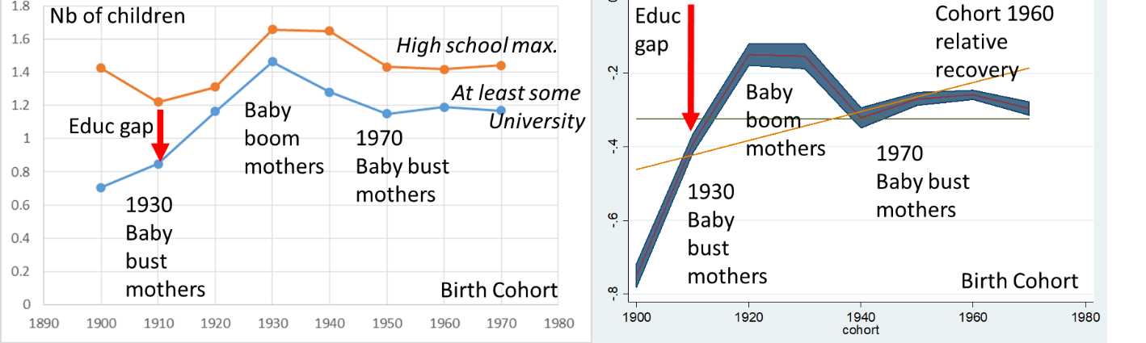Source: IPUMS US Censuses 1940-2010, authors’ calculations. Note: APC-GO, uncontrolled gap in number of children in the household between low and high educated women. Educational gap=N of kids among higher educated-N of kids among lower educated. Source: CPS, authors’ calculations.

In this second phase, concerning the cohorts of 1950-65, the ESF stagnates among higher educated but slowly continues to decrease among the lower educated leading to a decrease in the educational gap in ESF. This is followed by a third phase of a newly increasing educational gap in ESF among the cohorts born after 1965 (until 1980). The acceleration of the decreasing ESF happens at a faster pace among higher educated, increasing again the educational gap. It is thus crucial to understand what happens to the 1950/45 cohort (large educational gap) and the 1955/65 cohort (small educational gap) as these mark changes in these trends.
Figure 2: Cohort educational gaps in number of children - low and high educated women (APCT-go) CPS
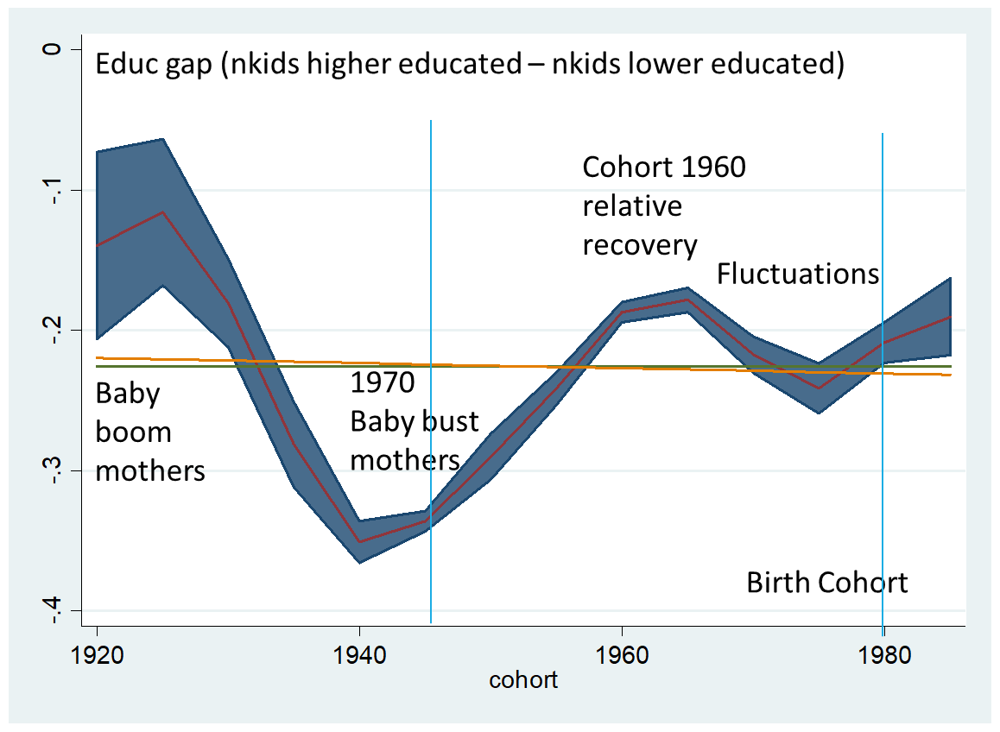
Note: APC-GO, uncontrolled gap in number of children in the household between low and high educated women. Source: IPUMS US CPS 1965-2017, authors’ calculations.
In long run analyses, the role of education is often discussed: are the differences in outcomes (here: ESF) due to absolute threshold of education, or to a relative place on the scale (top/bottom decile, etc.): is education a positional good? This is of particular importance when we compare generations with 16% higher educated women (for U.S. women of cohort born in 1920) with others with 67% (for U.S. women of cohort born in 1980). In the American case, the bump of the cohorts born in the 1960s is well established in both coding of education.
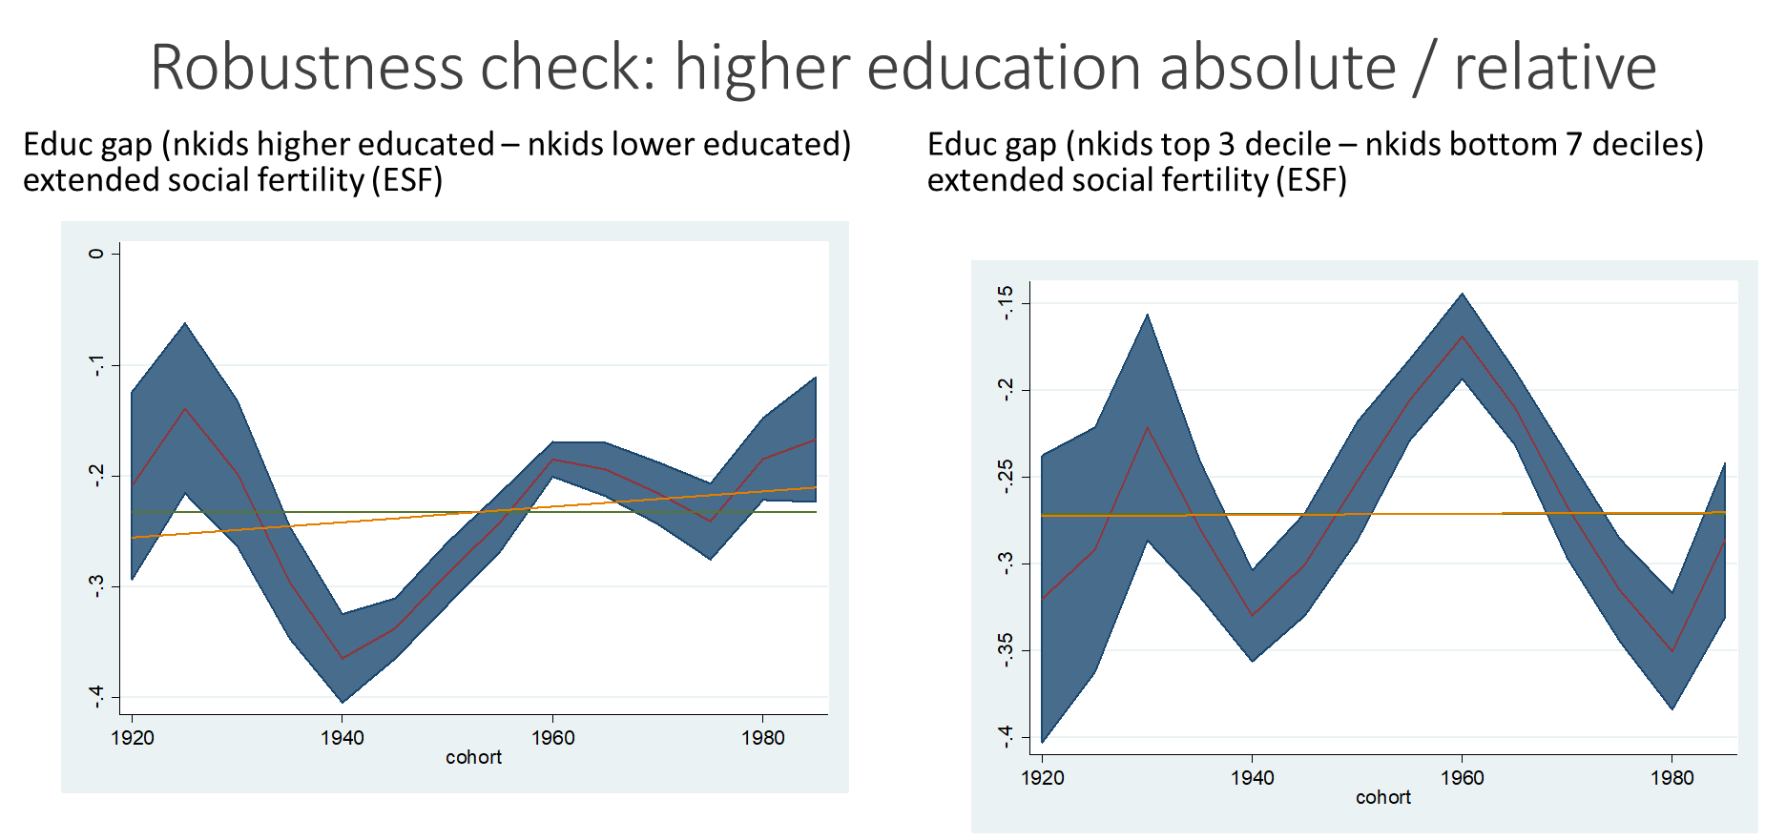

A cross-national comparison of ESF in nine countries
We begin with providing descriptive trends of fertility among tertiary and non-tertiary educated women in nine countries (Figure 3). In many countries, there was a decline in fertility over cohorts. The strongest decline was recorded in Taiwan where the difference between the cohort born in 1945 and the cohort born in 1980 was more than one child in average. This is due to the relatively higher level of fertility for the oldest cohort. Taiwan, who started with the highest level of fertility in the sample, closed the gap with the other countries rapidly. In the US, France and the Nordic countries, the number of children remained relatively stable across cohorts.

Figure 3: Trends in extended social fertility (ESF) by educational levels (tertiary and non-tertiary) across birth cohorts among women in 9 countries
Source: LIS data, authors’ calculations.
Regarding differences in fertility by educational levels, in most countries the lower educated women had more children than the higher educated. The exception are the Nordic countries where there were almost no differences between the higher educated and the lower educated. This is in line with previous studies (Andersson et al. 2009), which found no differences in fertility over educational level in the Nordic countries, once controlling the age factor.

Figure 4: Educational gap (tertiary vs. non-tertiary) in extended social fertility (ESF) across birth cohorts among women in nine countries
Source: LIS data, authors’ calculations.
We show the fertility gap between the tertiary educated and the non-tertiary educated in Figure 4. Overall, we can see three key patterns. The first is no differences in the ESF gap by education, neither in level nor in the trend with almost no significant fluctuations across cohorts. This is the case in the three Nordic countries Denmark, Finland and Norway. With the exception of the German cohort born in 1945, ESF is always higher among lower educated. But the level and the cohort trends differ across and within countries. In countries such as Taiwan, France and the US until cohort 1965, the educational differences in ESF are shrinking, while in Germany, Great Britain and Italy until cohort 1960, the educational gap is widening.

Discussion
This article has analysed the trends in extended social fertility (ESF), measured with a wider definition comprising the number of children living in the household, in nine countries. This definition is distinct from the demographic definition of fertility but is sociologically meaningful as it comprises not only biological children but also foster and step children. Based on our results, we conclude that there is no homogeneous trend in the differences in the number of children between high and low-educated women across countries and attribute our findings to micro-level explanations as well as historical and institutional contexts including educational expansion and labor market transformations.
Different parallel trends have affected low and high educated differently and may thus explain our findings, most notably the feminization of higher education. Due to the massive educational expansion of the second half of the twentieth century, women caught up and even surpassed men in terms of attainment of tertiary education (DiPrete and Buchman 2013). The educational expansion began earlier in the US than in other countries starting with the cohorts born in 1960-1965, while in Finland and Israel, the expansion was not linear, with a substantial shift in the proportion with tertiary education for the cohorts born in 1970-1975 (Bar-Haim et al. 2017). A massive educational expansion, and thus feminization, occurred in many countries during the 1990’s, when these cohorts entered the higher education system (Marginson 2016, Liu, Green & Pensiero 2016).
With increasing educational credentials and skills, also labour market participation has increased among women. Due to longer time spent in education and increasing shares of women in work, family decisions including childbearing have been postponed. This effect should be visible as a widening educational gap as ESF of higher educated women slows down. Given biological fertility limits (age) also the introduction of technologies improving fertility are likely to play a relevant role.
Likewise, birth prevention technology and changes in family recomposition behavior may have affected the ESF of both educational groups differently. Although birth control was available since the 1960s, it was not legalized for all women in the entire US until 1972. Increasing levels of education among women and postponement of marriage were consequences that have been labelled as the “power of the pill” (Goldin and Katz 2002). Besides diverging family preferences and choices, also the prevalence of unintended pregnancies has been found to higher among the low educated, being one possible reason for higher number of children among lower educated women. Then also the legalization of abortion in 1973 in the US may have affected the educational gap in ESF as lower educated or women from lower income groups seem to be more likely to have an abortion (Väisänen 2015, Jerman et al. 2016). Jerman et al. (2014) report that three out of four abortion patients in the US were low income in 2014: about half in poverty and another quarter below 200% of the poverty level. Indeed, the increasing abortion rate after 1973 and its high level throughout the 1980s seems to coincide with the lower educational gap among cohorts born between the 1955 and 1965. The subsequent decline in abortion until the mid-2000s coincides with an increasing educational gap in ESF of younger cohorts.

Acknowledgements
We would like to thank Tereza Wennerholm-Caslavska for her contribution to an earlier version of the paper and Anja Leist for her reading of an earlier version.

References
Andersson, G., Knudsen, L.B., Neyer, G., Teschner, K., Ronsen, M., Laèèegard, T. Skrede, K. and Vikat, A. (2009). Cohort fertility patterns in the Nordic countries. In: Demographic Research, 20, 14: 313-352, http://www.demographic-research.org/Volumes/Vol20/14/ - DOI: 10.4054/DemRes.2009.20.14
Bar-Haim, E., Chauvel, L. & Hartung, A. (2017). More Necessary and Less Sufficient: An Age-Period-Cohort Approach to Overeducation in Comparative Perspective. Working paper.
Billari, F.C. & D. Philipov (2004). Education and the transition to motherhood: a comparative analysis of Western Europe. European Demographic Research Paper 2004/3, Vienna Institute of Demography, Austrian Academy of Sciences.
Bhrolcháin, M.N. & É. Beaujouan (2012). Fertility postponement is largely due to rising educational enrolment, Population Studies 66(3): 311–327.
Blossfeld, H.P. & J. Huinink (1991). Human capital investments or norms of role transition? How woman’s schooling and career affect the process of family formation, American Journal of Sociology 97(1): 143–168.
Chauvel, L. & Schröder, M. (2014). Generational inequalities and welfare regimes. Social Forces, 92(4), 1259-1283.
Chauvel, L., Hartung, A. & Bar-Haim, E. (2017). Closing or persisting gender wage gap? A cohort analysis of education and wages in the US and Europe. Conference Paper, PAA 2017.
Chauvel, L., Leist, A. K., & Ponomarenko, V. (2016). Testing persistence of cohort effects in the epidemiology of suicide: an age-period-cohort hysteresis model. PloS one, 11(7), e0158538.
Cohen, J.E., Ø. Kravdal & N. Keilman (2011). Childbearing impeded education more than education impeded childbearing among Norwegian women, Pro- ceedings of the National Academy of Sciences 108(29): 11830–11835.
DiPrete, T. A., & Buchmann, C. (2013). The rise of women: The growing gender gap in education and what it means for American schools. Russell Sage Foundation.
Easterlin, R.A. (1966). On the relation of economic factors to recent and projected fertility changes, Demography 3(1): 131–153.
Esping-Andersen, G. (2009). The Incomplete Revolution: Adapting Welfare States to Women's New Roles. Cambridge, UK: Polity Press.
Esping-Andersen, G. & Billari, F.C. (2015). Re-theorizing Family Demographics. Population and Development Review, 41: 1–31. doi:10.1111/j.1728-4457.2015.00024.x
Flood, S., King, M., Ruggles, S. and Warren, J. R. (2017). Integrated Public Use Microdata Series, Current Population Survey: Version 5.0. [dataset]. Minneapolis: University of Minnesota, https://doi.org/10.18128/D030.V5.0.
Goldin, C. & F. Katz L. (2002). The Power of the Pill: Oral Contraceptives and Women’s Career and Marriage Decisions. Journal of Political Economy 110: 730-770.
Gustafsson, S. & A. Kalwij (Eds) (2006). Education and Postponement of Maternity. Economic Analyses for Industrialized Countries. Dordrecht, NL: Kluwer Academic Publishers.
Hagestad, G.O. & V.R.A. Call (2007). Pathways to childlessness: a life course perspective, Journal of Family Issues 28(10): 1338–1361.
Hazan, M. & Zoabi, H. (2015), Do Highly Educated Women Choose Smaller Families? Econ J, 125: 1191–1226. doi:10.1111/ecoj.12148
Jalovaara, M., Neyer, G., Andersson, G., Dahlberg, J., Dommermuth, L., Fallesen, P. & Lappegård, T. (2017). Education, gender, and cohort fertility in the Nordic countries. Stockholm Research Reports in Demography 2017: 6.
Jerman, J., R.K. Jones & T. Onda (2016). Characteristics of U.S. Abortion Patients in 2014 and Changes Since 2008, New York: Guttmacher Institute.
Kneale, Dylan & Heather Joshi. (2008). Postponement and childlessness – evidence from two British cohorts, Demographic Research 19(58): 1935–1968.
Kravdal, Ø. & R.R. Rindfuss. (2008). Chan- ging relationships between education and fertility – a study of women and men born 1940–64, American Sociological Review 73(5): 854–873.
Liefbroer, A.C. & M. Corijn (1999). Who, what, where, and when? Specifying the impact of educational attainment and labour force participation on family formation, European Journal of Population 15: 45–75.
Lutz, W. (2013). Demographic metabolism: A predictive theory of socioeconomic change. Popul. Dev. Rev. 38, 283–301.
Mason, W. M., & Wolfinger, N. H. (2001). Cohort analysis, International Encyclopedia of the Social & Behavioral Sciences. Oxford: Pergamon. p. 2189-94.
Michael, R. T. (1975). Education and fertility. In: F.T. Juster (ed) Education, income, and human behaviour, NBER, 339-364.
Ruggles, S., Genadek, K., Goeken, R., Grover, J. and Sobek, M. (2017). Integrated Public Use Microdata Series: Version 7.0 [dataset]. Minneapolis: University of Minnesota, https://doi.org/10.18128/D010.V7.0.
Ryder, N.B. (1965). The Cohort as a Concept in the Study of Social Change. American Sociological Review, 30: 843-861.
Shang, Q. & Weinberg BA. (2013). Opting for families: recent trends in the fertility of highly educated women. Journal of Population Economics 26: 5-32.
Smith, H. L. (2008). Advances in age–period–cohort analysis. Sociological Methods & Research, 36(3), 287-296.
Tavares, L. (2010). Who Delays Childbearing? The Relationships between Fertility, Education and Personality Traits. Dondena Working Paper 9. Milan: Dondena Center for Research on Social Dynamics.
UN (United Nations) (2009). Child Adoption: Trends and Policies. Department of Economic and Social Affairs, Population Division.
Väisänen, H. The association between education and induced abortion for three cohorts of adults in Finland. Population Studies. 2015;69(3):373-388. doi:10.1080/00324728.2015.1083608.
Whelpton, P.K. (1949). Cohort Analysis of Fertility. American Sociological Review, 14: 735-749.
Whelpton, P.K. (1954). Cohort Fertility. Native White Women in The US, Princeton, Princeton University Press.

Some scholars have made attempts to integrate these two approaches (Kravdal & Rindfuss, 2008).
As a robustness check, we repeated the analysis using the number of household members under age 17 and retrieved similar results.
Our results are robust to different samples, i.e. the exclusion of non-White population and different age selections.
This may be explained (partly) by selection into education (Väisänen 2015).

